- First Web Api using .Net core

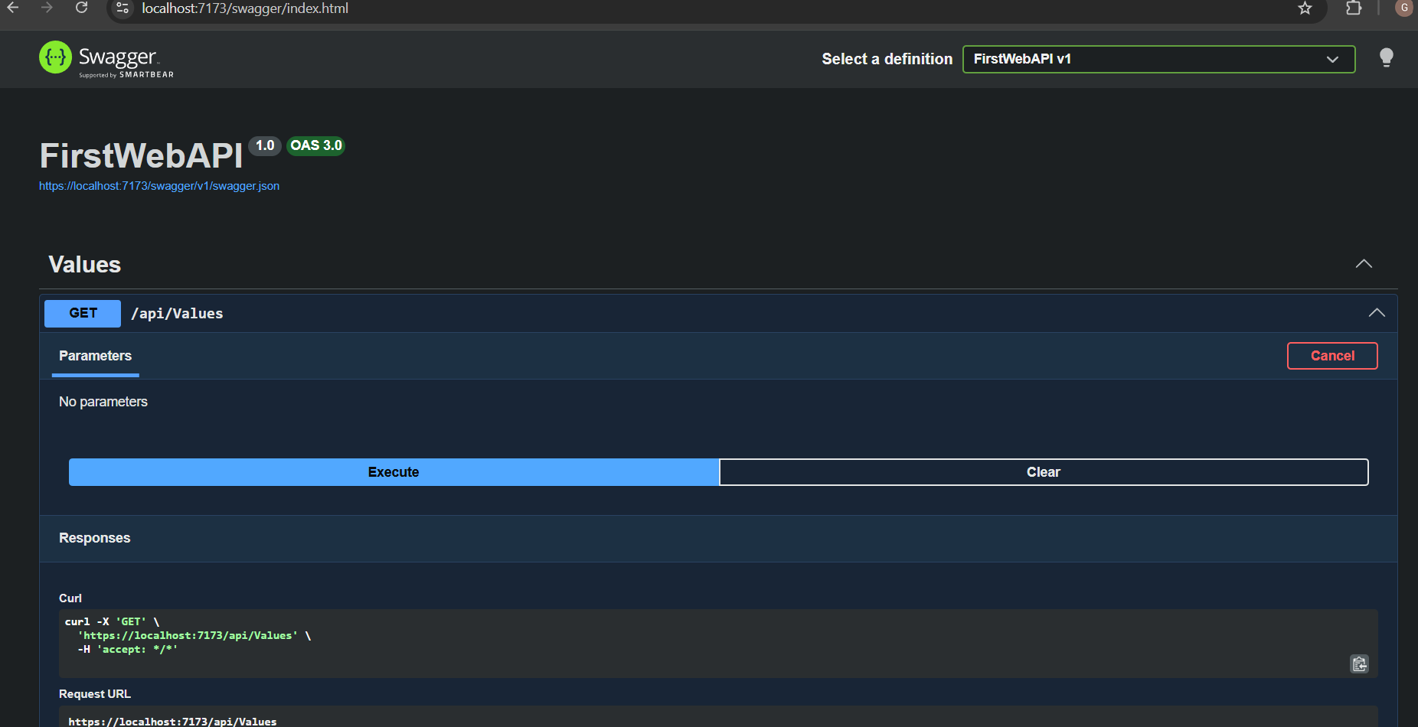
Figure 1: Swagger UI displaying the GET /api/Values endpoint.

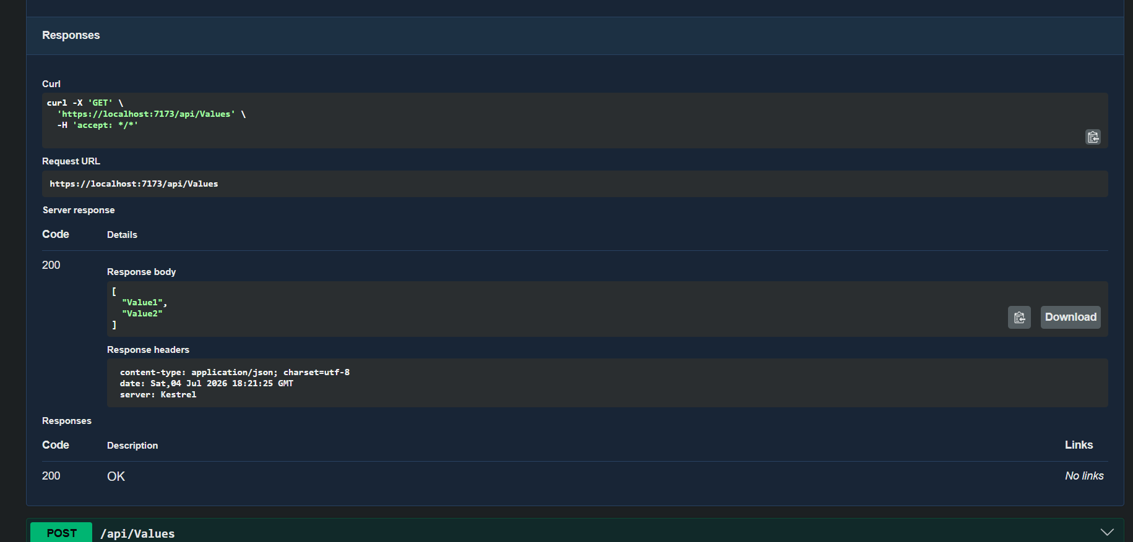
Figure 2: Successful execution of the GET request in Swagger with HTTP Status 200 OK and the response body.
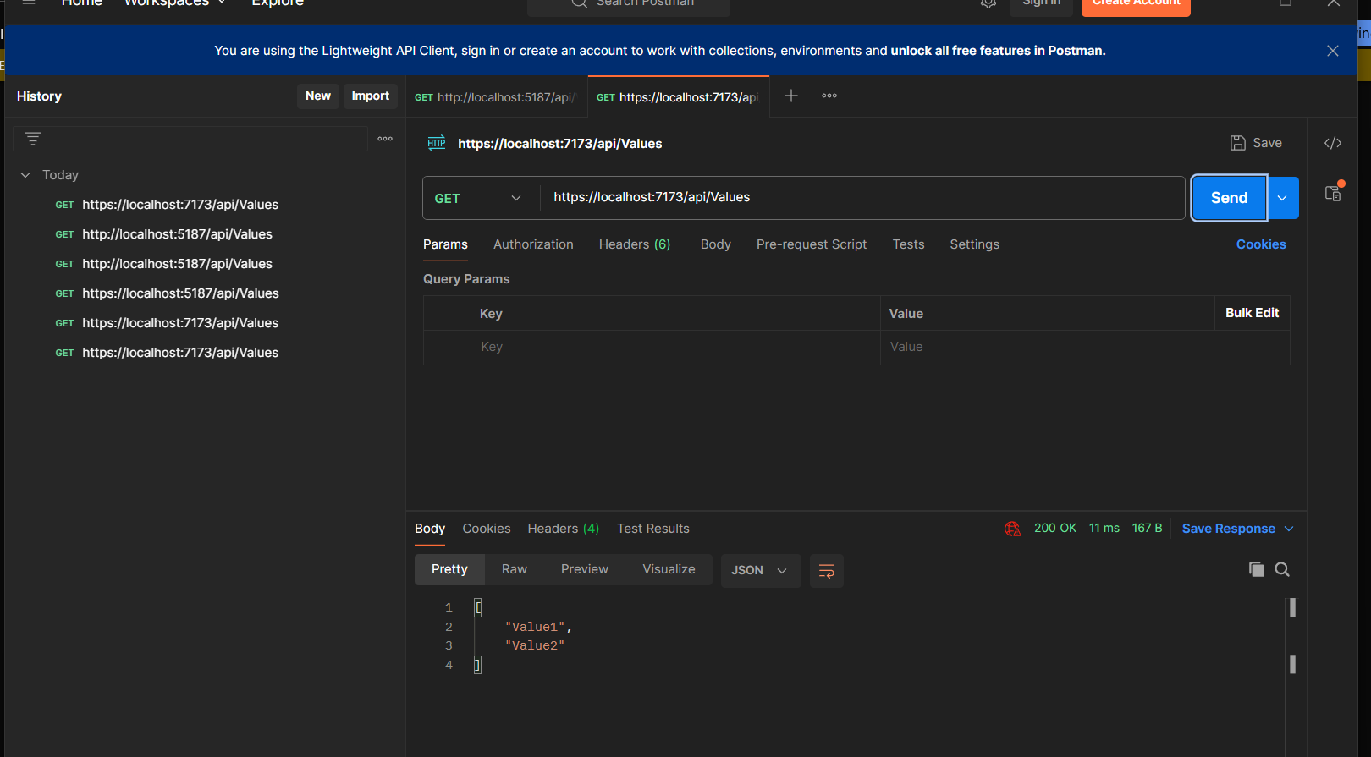
Figure 3: Successful execution of the GET request in Postman with HTTP Status 200 OK and the response body.

